Programmable multistep radical dechlorinative functionalization of polychloroarenes through hierarchical active learning
xxx, xxx, xxx*
State Key Laboratory of Precision and Intelligent Chemistry, Anhui Provincial Key Laboratory of Biomass Chemistry, Department of Chemistry, University of Science and Technology of China, Hefei, Anhui 230026, China.
xxx
*e-mail:

Abstract: Precise and programmable editing of complex molecules remains a central ambition of chemical synthesis, yet achieving site selectivity among multiple nearly indistinguishable reactive centres is still a formidable challenge. Polychloroarenes exemplify this problem because their sequential functionalization is governed by a evolving reactivity profile moving reactivity landscape, in which each dechlorination event reshapes the activation requirements of the remaining C–Cl bonds and frustrates conventional condition screening. Here we report a reactivity-guided hierarchical active learning strategy that transforms intrinsic chemical hierarchy into an organizing principle for data-driven discovery. Rather than treating multistep functionalization as a set of disconnected optimization tasks, we structured the search as a staged progression through nested reactivity windows, in which each round identifies productive conditions for the current activation event while excluding overly strong regimes that would obscure subsequent, milder transformations. Using this strategy, we navigated a condition space of 205,632 combinations with only 270 experiments across three stages and uncovered orthogonal condition sets for meta-, ortho-, and para-selective C–Cl activation. The resulting workflow enabled programmable multistep dechlorinative functionalization of polychloroarenes with broad alkene scope, strong functional-group tolerance, and downstream access to densely substituted arenes and macrocyclic scaffolds. More broadly, this work establishes a general paradigm in which latent chemical order is converted into predictive search order, providing a bottom-up blueprint for solving stage-dependent selectivity problems in complex chemical space. More broadly, this work provides a blueprint for active learning-guided control of sequential site selectivity in complex chemical space.

Introduction
Selectivity control lies at the heart of modern synthesis, as it determines whether readily available molecules can be transformed directly into complex, densely functionalized architectures. Achieving this ideal requires strategies that can distinguish closely related reactive sites and coordinate multiple transformations in a programmed sequence, a level of control that remains extremely rare in current synthetic chemistry. Among existing approaches, directing group strategies have been particularly powerful, using induced proximity to impose selective reaction at otherwise challenging positions. A complementary challenge arises where site selectivity cannot be imposed by a single directing element, but must instead be programmed across multiple nearly indistinguishable reactive sites in a defined sequence. Polychloroarenes bring this challenge into sharp focus. They are abundant and versatile synthons for the construction of densely substituted aromatic frameworks, yet their controlled functionalization through selective C–Cl bond activation has remained exceptionally difficult (Figure 1A). Typical reaction conditions rarely discriminate cleanly among these closely related C–Cl bonds, and sequential transformations are further complicated by a moving reactivity landscape: each dechlorination event renders the remaining C–Cl bonds less reactive, such that every subsequent step demands a newly matched activation regime. Although metal-catalysed cross-coupling has enabled editing of polyhalogenated arenes in selected cases²⁻⁴, these advances have not delivered a general solution for programmable multistep control. Radical-promoted dechlorinative functionalization presents an attractive alternative, as radical reactivity is highly tunable. Radical-promoted dechlorinative functionalization presents an attractive alternative, as the effective strength of C–Cl activation can be adjusted over a broad range. Yet this same tunability also creates a vast combinatorial condition space that quickly overwhelms empirical screening. What is needed is not another round of trial and error, but a predictive strategy that can discover the right reactivity window for each step.
Machine learning has begun to transform reaction condition discovery by enabling efficient exploration of high-dimensional chemical spaces(1–6). Model-guided optimization, including Bayesian optimization and closed-loop experimentation(7–10), has shown that algorithms can accelerate the identification of high-performing conditions beyond what intuition alone can reliably achieve. But programmable multistep dechlorinative functionalization poses a fundamentally different problem. The goal is not to locate a single optimum in a fixed condition space. It is to discover a sequence of mutually compatible condition sets that can be called upon in a controlled order. This distinction is crucial. If each dechlorination step is optimized independently, strongly activating conditions will repeatedly dominate the search, because conditions capable of activating a less reactive C–Cl bond will inevitably also activate more reactive ones. Independent optimization therefore obscures, rather than resolves, the stage-specific selectivity problem. A viable solution must instead exploit the intrinsic hierarchy of C–Cl bond reactivity and use that hierarchy to organize the search itself. Predictive frameworks capable of this type of stage-dependent condition discovery have yet to be established.
Here we report a reactivity-guided hierarchical active learning strategy that converts intrinsic stepwise reactivity differences into the organizing principle for condition discovery. Rather than treating multistep dechlorination as a collection of disconnected optimization tasks, we structured the search as a staged progression through successively narrower reactivity windows (Figure 1B). Each stage was designed not only to identify conditions matched to the current activation event, but also to define and exclude overly strong regimes that would interfere with subsequent, milder transformations. In this way, latent chemical order was translated into search order. The result is a bottom-up discovery workflow in which prediction and experiment operate in a closed-loop to progressively carve a chemically meaningful path through a large condition space. Predictions from one stage therefore constrained the search space for the next, progressively separating the original condition manifold into distinct activation windows for meta-, ortho-, and para-selective C–Cl functionalization. In this way, active learning was used not only to choose new experiments, but also to organize the search space according to the stepwise reactivity requirements of sequential dechlorination.
Applying this strategy to boryl radical-promoted dechlorinative functionalization, we explored a condition space of 205,632 combinations defined by five variables using only 270 active learning guided experiments across three stages. This workflow unlocked distinct condition sets for meta, ortho, and para selective C–Cl activation, enabling programmable multistep dechlorinative functionalization of polychloroarenes with broad alkene scope, strong functional group tolerance, and further diversification into densely substituted arenes and macrocyclic scaffolds (Figure 1C). More broadly, this work demonstrates how data-driven search can be integrated with intrinsic reactivity differences to solve stage-dependent condition discovery in complex multistep transformations, thereby opening a general route to programmable molecular editing in complex polyfunctional molecules.
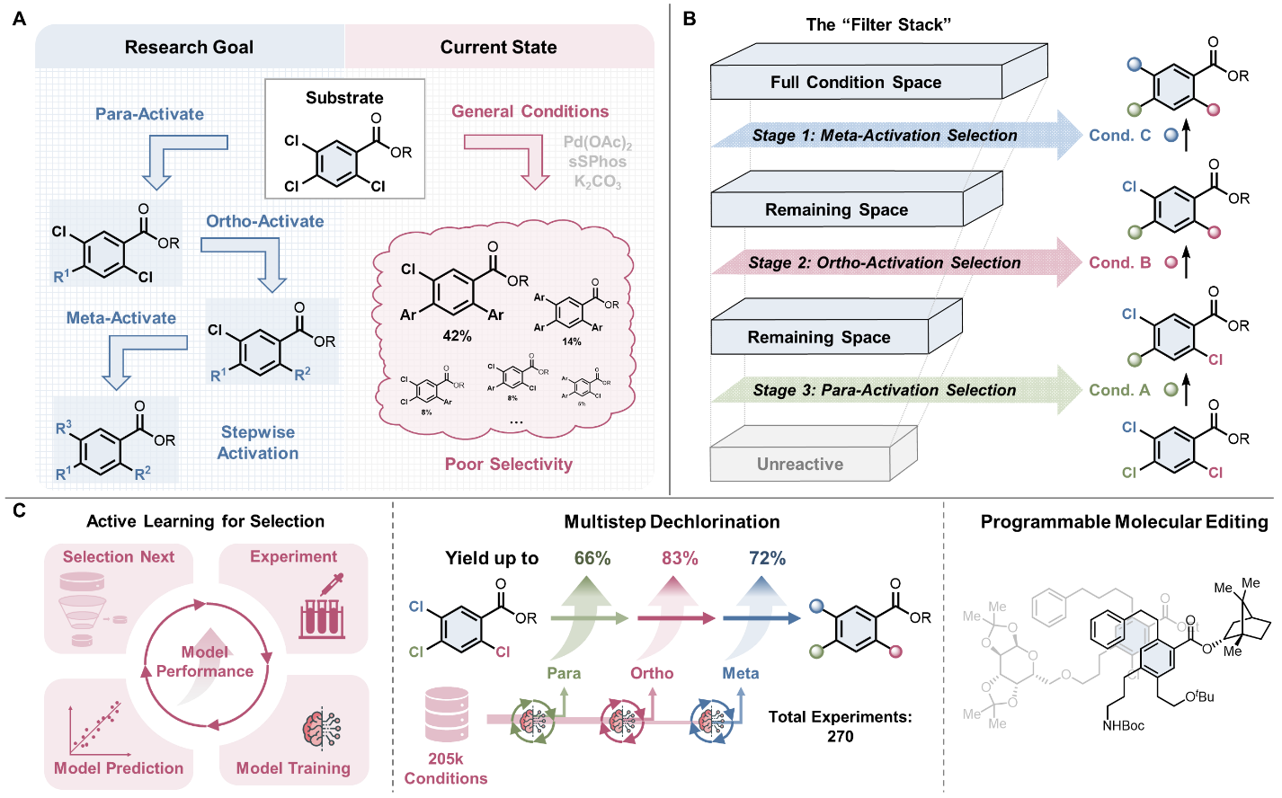
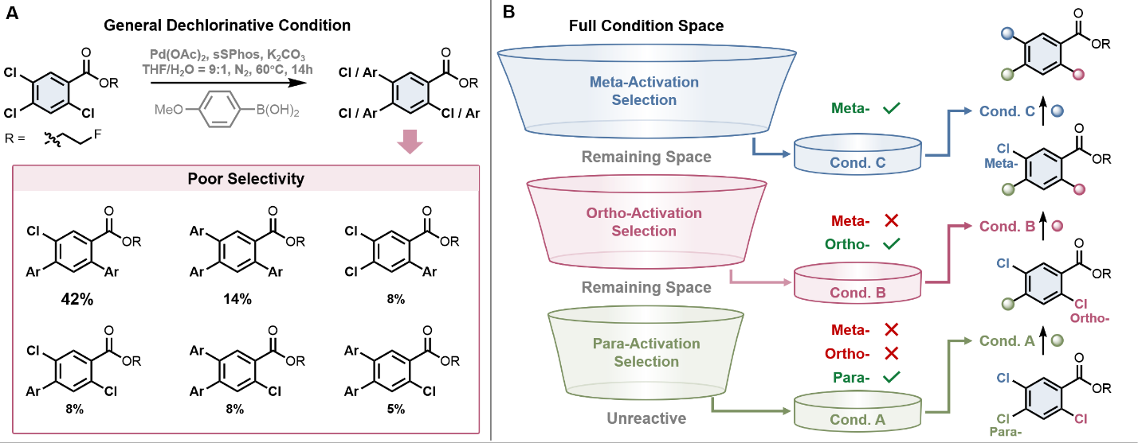
Figure 1. Reactivity-guided hierarchical active learning for programmable multistep dechlorinative functionalization of polychloroarenes. (A) Synthetic challenge in programmable multistep dechlorinative functionalization of polychloroarenes. (B) Reactivity-guided hierarchical active learning strategy for stage-dependent condition discovery. (C) Synthetic performance and applications of the data-driven discovered boryl radical-promoted dechlorinative functionalization conditions.

Results and discussion
Design of reactivity-guided hierarchical condition discovery
Lewis base-ligated boryl radicals offered

Lewis base-ligated boryl radicals have emerged as powerful open-shell reagents for carbon–halogen bond activation, enabling the cleavage of otherwise challenging C–X bonds through tunable radical pathways. This reactivity makes them an ideal platform for programmable multistep dechlorinative functionalization because their reactivity can be tuned across a wide continuum. Variation of the Lewis base, boron substituents, radical-quenching manifold reagent, solvent, and stoichiometry can all reshape the effective activation strength of the system can all change how readily the reaction system cleaves C–Cl bonds. In the working model for dechlorinative alkylation (Fig. 2A), initiation of a Lewis base–borane complex generates a ligated boryl radical, which activates the aryl chloride through halogen-atom transfer to form an aryl radical. Subsequent alkene addition and hydrogen-atom transfer deliver the alkylated product, while the thiol component participates in radical quenching and completes the catalytic cycle. This mechanistic picture provides several chemically meaningful handles for tuning the ease of C–Cl bond cleavage and product formation. The Lewis base–borane structure and stoichiometry modulates boryl-radical generation and halogen-atom transfer, the thiol component affects radical quenching, the initiator controls radical generation, and the solvent shapes the overall reaction environment. Together, these features make the system highly adjustable, but also intrinsically high-dimensional.
Rather than viewing this multi-parameter tunability as a complication, we recognized it as the chemical basis for stage-specific control. If distinct reactivity windows could be identified within this condition manifold, they could in principle be matched to successive C–Cl activation events during stepwise dechlorination. Guided by our previous studies on boryl radical-mediated carbon–halogen bond activation, we therefore constructed a multidimensional condition space comprising 24 Lewis bases, 14 thiols, 9 initiators, 17 solvents, and 4 stoichiometries, corresponding to 205,632 possible reaction conditions (Figure 2B). This expansive landscape created the opportunity for precise control, but also rendered conventional empirical screening fundamentally inadequate.
The central challenge in this space was not to identify a single globally optimal condition. It was to discover a sequence of chemically orthogonal condition sets, each matched to a distinct C–Cl activation event. This problem differs fundamentally from conventional reaction optimization. The candidate conditions in this system do not behave as unrelated discrete options. They span an ordered continuum of activation capability, from highly aggressive regimes to milder and more selective ones. A condition strong enough to activate a less reactive C–Cl bond will inevitably also activate more labile sites, and would therefore appear deceptively effective if each stage were optimized in isolation. Such a strategy would repeatedly reward overactive conditions, obscure the boundaries between activation windows, and ultimately frustrate programmable control. We therefore reformulated the problem from condition optimization to hierarchical boundary discovery: the task was not merely to find productive conditions, but to identify where one activation regime must end so that the next one can begin.
On this basis, we designed a reactivity-guided hierarchical condition discovery framework (Fig. 2C). The search was organized into successive meta-, ortho-, and para-selection stages, each performed within an admissible subspace defined by the results of the preceding stage. Crucially, each stage served a dual role. It had to uncover conditions capable of promoting the current target transformation, and at the same time delineate the activation boundary that would constrain the next search. In the first stage, the full condition space was interrogated to identify conditions capable of activating the least reactive meta-C–Cl bond. Once this boundary had been learned, all conditions predicted to give 20% or higher yield for meta activation were excluded from the subsequent ortho-stage search, thereby removing regimes that were too strong to preserve stage-specific control. The same logic was then imposed between the ortho and para stages. Through this progressive exclusion, the original 205,632-member space was not merely reduced in size; it was chemically restructured into a sequence of increasingly selective reactivity windows. In this way, intrinsic differences in C–Cl bond reactivity were translated into an ordered search trajectory, enabling data-driven discovery of condition sets suited to programmable multistep C–Cl activation.
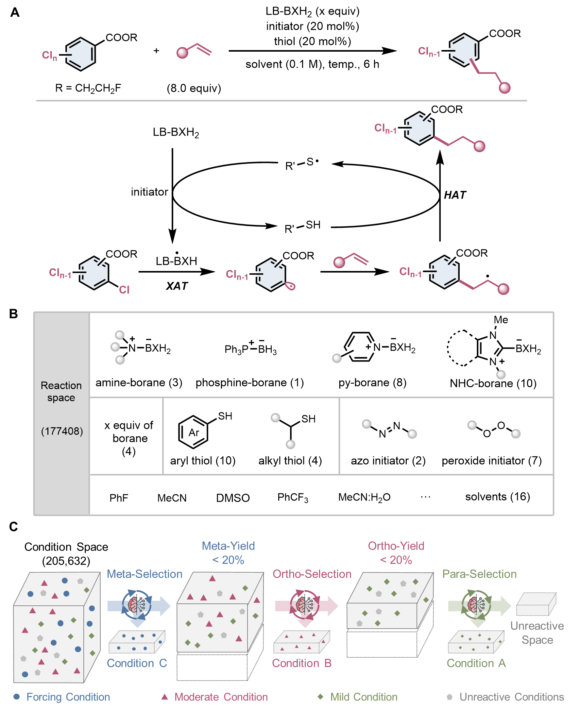
Figure 2. Hierarchical condition discovery for stage-specific boryl radical-promoted dechlorinative functionalization. (A) Model reaction and definition of the multidimensional condition space for boryl radical-promoted dechlorinative functionalization of polyarenes. (B) Designed framework of reactivity-guided hierarchical condition discovery, in which the full condition space is progressively filtered through meta-, ortho-, and para-selection stages using a 20% predicted-yield cutoff between successive stages.
Discovery of selective conditions for sequential C–Cl activation
To navigate the hierarchical discovery strategy, we next transformed the discrete condition manifold into a learnable reactivity landscape. Each candidate reaction was encoded using DFT-computed physical organic descriptors that capture the geometric, steric, and electronic features related to C–Cl activation across the five dimensions of the search space, thereby embedding chemically distinct condition combinations within a unified 35-dimensional representation (Fig. 3A)(6, 11). Reaction yield was modelled using CatBoost regression, and experiment prioritization was directed by an upper confidence bound acquisition function that balanced predicted performance against model uncertainty.
The first stage targeted the most demanding activation event, selective cleavage of the meta-C–Cl bond in 2-fluoroethyl 3-chlorobenzoate, and surveyed the full set of 205,632 candidate reaction conditions. Starting from 50 randomly selected experiments, active learning advanced in batches of 10 until the target yield exceeded 80% or improvement stalled over two consecutive rounds. After seven rounds, the model reached a cross-validated R² of 0.702 with a mean absolute error (MAE) of 9.93% and pinpointed Condition 1 (Fig. 3B): DMAP-BH₃, DTBP, 3,5-diCF₃C₆H₃SH, and CH₃CN/H₂O (3:1). This combination furnished the desired dechlorinative alkylation product in 72% yield (Fig. 3E). The trained model then flagged 2,751 meta-active conditions, and excluding this higher-reactivity manifold opened the ortho-selective search window.
The second stage resumed active learning within this filtered space, now targeting selective cleavage of the ortho-C–Cl bond in 2-fluoroethyl 2,5-dichlorobenzoate while incorporating the meta-stage data into model training. After six additional rounds, the model improved to a cross-validated R² of 0.784 with a MAE of 9.83% and pinpointed Condition 2 (Fig. 3C): DMAP-BH₃, ABVN, 2-COOMeC₆H₄SH, and CH₃CN/H₂O (3:1). This condition delivered the ortho-selective dechlorinative alkylation product in 83% yield (Fig. 3E). The trained model then flagged 12,932 ortho-active conditions, and their exclusion compressed the search into a narrower window containing 189,949 candidate conditions. Within this doubly filtered space, the third stage targeted para-selective activation of 2-fluoroethyl 2,4,5-trichlorobenzoate. Across nine additional rounds, the model maintained robust performance, reaching a cross-validated R² of 0.731 with an MAE of 9.31%, and identified Condition 3 (Fig. 3D): m-OMePy-BH₃, DTBPc, 3,5-diCF₃C₆H₃SH, and CH₃CN. This mildest activation regime delivered the para-selective dechlorinative alkylation product in 66% yield as the major product (Fig. 3E), revealing that weaker yet synthetically productive reactivity windows emerged only after the stronger manifolds had been systematically stripped away.
The conditions uncovered through hierarchical active learning define an ordered ladder of activation windows that mirrors the intrinsic reactivity hierarchy of the three C–Cl sites. Their distinction is reflected not only in the stage-specific outcomes, but also in their crossover behaviour beyond the intended search stage. When Condition 1 was applied to downstream dichloro- and trichloroarenes, it gave mixtures arising from multiple dechlorinative functionalization events rather than preserving single-site control (Fig. 3E). Condition 2 similarly lost selectivity on trichloro substrates, again leading to overfunctionalized mixtures (Fig. 3E). These crossover outcomes confirm that the earlier stages uncover stronger activation manifolds, whose exclusion is required to expose the weaker windows needed for subsequent selective editing.
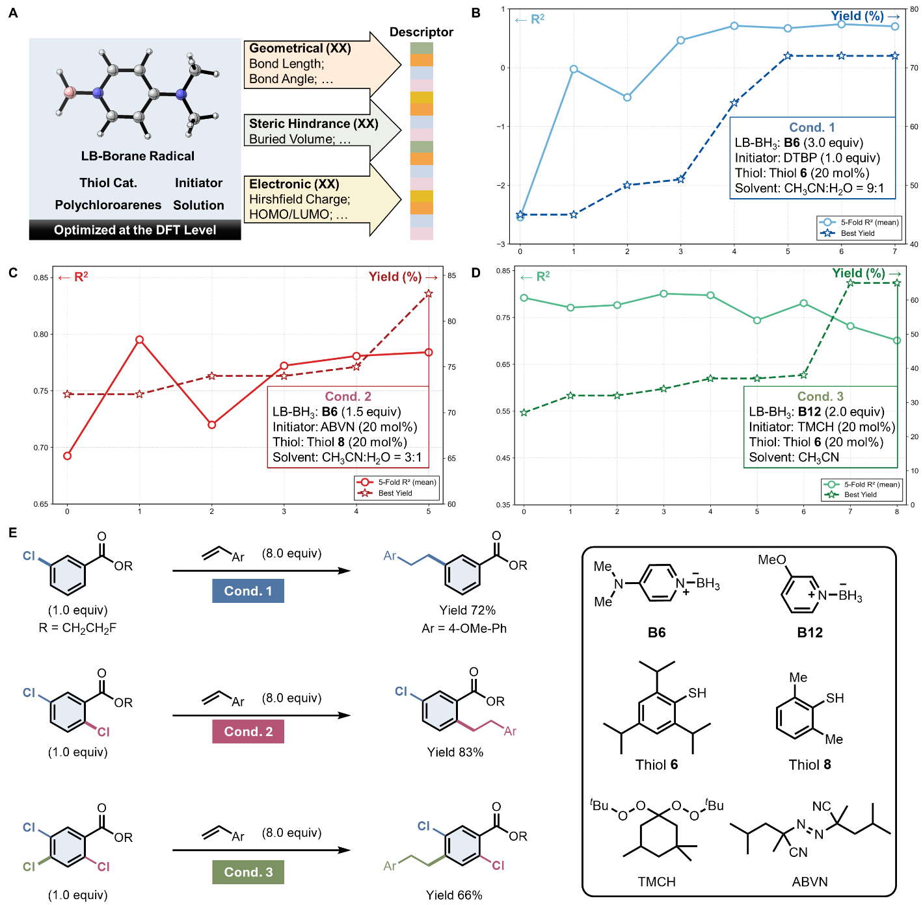
Figure 3. Reaction representation and active-learning-guided identification of selective conditions for sequential C–Cl activation. (A) Physical organic reaction representation of the boryl radical-promoted dechlorinative alkylation condition space. (B–D) Active learning trajectories for identifying the meta-, ortho-, and para-selective conditions across progressively filtered reactivity windows. (E) Experimental validation of the three conditions discovered for stage-specific dechlorinative alkylation.

Synthetic scope and programmable diversification
To experimentally validate the conditions uncovered through hierarchical active learning, we first examined their performance in sequential, site-selective radical dechlorinative functionalization (Fig. 4). Under Condition 1, ethyl ester-substituted 2,4,5-trichloroarenes coupled smoothly with a broad range of aliphatic alkenes spanning different chain lengths, furnishing the corresponding products 1a–1d in good to high yields. Notably, the alkene derived from diacetone-D-galactose also proved to be a competent partner, providing 1e and highlighting a viable entry to the structural diversification of this sugar derivative. Variation of the ester moiety was likewise well tolerated, including 4-fluorophenyl (1f), fluoroethyl (1g), and derivatives of (–)-borneol (1h), (–)-menthol (1i), diacetone-D-glucose (1j) and estradiol 3-methyl ether (1k), all delivering the corresponding products with high yields and site selectivity. In these cases, only a minor amount (≤10%, see Supplementary Information for details) of dechlorinative alkylation at the ortho-position was observed as a side reaction, indicating that the data-driven discovered condition captures a practically useful balance between reactivity and positional control.
We further examined selective cleavage of the second C–Cl bond in the resulting 2,5-dichloroarenes under Condition 2. Despite the lower intrinsic reactivity of these substrates, a broad range of alkenes remained compatible, including aliphatic partners with varied chain lengths and electronic properties (2a, 2b and 2i), as well as diverse aromatic (2c–2h) and heteroaromatic (2j) alkenes, furnishing the corresponding products with high efficiency and excellent site selectivity (Fig. 4). The structure of 2d was confirmed by X-ray crystallography. Guided by the stage-resolved conditions uncovered through hierarchical active learning, the sequence could be advanced to a third dechlorinative alkylation step to deliver densely substituted trialkylated arenes 3a–3i with retained regioselective control. These results establish that the data-driven discovered conditions function not as isolated solutions for individual steps, but as a coordinated set of reactivity windows that enable programmable, multistep editing of polychloroarenes. Additional examples of sequential C–Cl functionalization are shown in Extended Fig. 1.
Fig. 4 | Experimental validation of optimized conditions and application to controlled multistep dechlorinative functionalization of 2,4,5-trichloroarenes. ª3.0 equiv of Bx and 50 mol% TMCH were used.
Subsequently, the versatility of the site-selective radical dechlorination strategy was evaluated using polychloroarenes with diverse substitution patterns and chlorination numbers (Fig. 5). Electron-withdrawing ester- and trifluoromethyl-substituted 2,3,5- and 2,4,5-trichloroarenes proved compatible with Condition 1, affording the corresponding products 4a–4e in good yields and complete site selectivity. The transformation also extended to less reactive dichloroarenes, for which selective monoalkylation under Condition 2 delivered 5a–5i in good to high yields across diverse chlorine substitution patterns, with a clear preference for substitution at the ortho position over the para and meta positions.
As the substrate space broadened, the number and position of chlorine atoms, together with the identity and pattern of the substituents, were found to exert a pronounced influence on dechlorinative reactivity. In several cases, the originally optimized conditions became inefficient and failed to deliver the desired products. To address this shift in reactivity landscape, transfer learning was used to identify an alternative condition better suited to the expanded substrate space. Under Condition 2-II, a simple tetrachloroarene was smoothly converted to the corresponding monoalkylated trichloroarene 6a in good yield (Fig. 5). Tri- and dichloroarenes also proved compatible, including substrates bearing fluorine (6b and 6j), 2-fluorophenyl (6c), ester (6d and 6e), and trifluoromethyl (6f–6i) substituents. Less-activated monochloroarenes likewise participated under the optimized conditions, furnishing 6k–6m in moderate to high yields. Application of Condition 3 to more electron-rich tri- to monochloroarenes further enabled coupling with a broad range of alkenes to install alkyl side chains in moderate to high yields (7a–7j). Notably, in the absence of alkene coupling partner and thiol catalyst, a substrate bearing a benzyl ether side chain underwent intramolecular cyclization to give the tricyclic product 7b.
Beyond dechlorinative alkylation itself, the synthetic utility of the platform was further demonstrated through downstream diversification of the remaining C–Cl bonds. Subjecting the partially functionalized chloroarenes to Suzuki–Miyaura cross-coupling with aryl or alkenyl boronic acids under palladium catalysis furnished 8a–8c, enabling dechlorinative arylation and alkenylation (Extended Fig. 2a). In addition, treatment of substrates bearing two long alkenyl side chains with Grubbs-I catalyst triggered ring-closing metathesis to forge 16-, 19-, and 22-membered macrocycles (9a–9c; Extended Fig. 2b). These transformations further highlight that the stage-specific conditions discovered through hierarchical active learning can serve as a versatile entry to structurally diverse and synthetically complex chlorinated arene scaffolds.
Fig. 5 | Controlled multistep dechlorinative functionalization of structurally diversely (multi)substituted chloroarenes. ªTrace amount (5%) of ortho-substituted product. ^{b}chloroarene (xx mmol), DMAP-BH₃ (3.0 equiv), DTBP (2.0 equiv), K₂CO₃ (2.0 equiv) in MeCN:H₂O (9:1 v/v) at 120 ˚C for 12 h.
Conclusion
This study shows that stage-dependent selectivity in complex transformations can be solved by integrating intrinsic chemical logic with hierarchical active learning. Instead of treating multistep dechlorinative functionalization as a series of independent yield optimization tasks, we reformulated it as a problem of hierarchical boundary discovery, in which each stage must identify not only productive conditions for the current activation event, but also the reactivity limit beyond which subsequent, milder transformations would be masked. Applied to boryl radical-promoted dechlorinative functionalization, this strategy navigated a condition space of 205,632 combinations using only 270 experiments across three stages and uncovered distinct activation windows for meta, ortho, and para C–Cl cleavage. The resulting models delivered consistent predictive performance throughout the discovery sequence, reaching cross validated R² values of 0.702, 0.784, and 0.731 with mean absolute errors of 9.93%, 9.83%, and 9.31%, respectively. In this framework, mechanistic hierarchy does not merely rationalize the results after the fact; it determines how the search should proceed, while active learning provides an efficient way to traverse the resulting chemically ordered landscape.

At the synthetic level, the conditions uncovered through this framework function as a coordinated ladder of activation regimes rather than as isolated solutions for individual substrates. Hierarchical active learning identified successful condition sets for meta-, ortho-, and para-selective dechlorinative alkylation, enabling programmable multistep editing of polychloroarenes with retained regioselective control. These stage-resolved reactivity windows proved compatible with a broad range of aliphatic, aromatic, and heteroaromatic alkenes, tolerated diverse functional groups and complex molecule-derived fragments, and supported the controlled functionalization of structurally diverse tri-, di-, and monochloroarenes. The synthetic utility of the platform was further demonstrated through downstream diversification of the residual C–Cl bonds, including Suzuki–Miyaura coupling to access arylated and alkenylated products, as well as ring-closing metathesis to construct macrocyclic scaffolds. By converting a shifting reactivity landscape into an ordered sequence of callable activation regimes, this work provides a practical route to programmable molecular editing in complex polyfunctional molecules.

References
1. Palani, V., Perea, M. A. & Sarpong, R. Site-Selective Cross-Coupling of Polyhalogenated Arenes and Heteroarenes with Identical Halogen Groups. Chem Rev 122, 10126-10169 (2022).
2. Esteruelas, M. A., Herrero, J., López, F. M., Martín, M. & Oro, L. A. Dehalogenation of Polychloroarenes with HSiEt3 Catalyzed by an Homogeneous Rhodium−Triphenylphosphine System. Organometallics 18, 1110-1112 (1999).
3. Yamaguchi, M. & Manabe, K. Three-step synthesis of 2,5,7-trisubstituted indoles from N-acetyl-2,4,6-trichloroaniline using Pd-catalyzed site-selective cross-coupling. Organic &amp; Biomolecular Chemistry 15, 6645-6655 (2017).
4. Golding, W. A., Schmitt, H. L. & Phipps, R. J. Systematic Variation of Ligand and Cation Parameters Enables Site-Selective C–C and C–N Cross-Coupling of Multiply Chlorinated Arenes through Substrate–Ligand Electrostatic Interactions. Journal of the American Chemical Society 142, 21891-21898 (2020).
1. C. J. Taylor, A. Pomberger, K. C. Felton, R. Grainger, M. Barecka, T. W. Chamberlain, R. A. Bourne, C. N. Johnson, A. A. Lapkin, A brief introduction to chemical reaction optimization. Chem. Rev. 123, 3089–3126 (2023).
2. N. I. Rinehart, R. K. Saunthwal, J. Wellauer, A. F. Zahrt, L. Schlemper, A. S. Shved, R. Bigler, S. Fantasia, S. E. Denmark, A machine-learning tool to predict substrate-adaptive conditions for pd-catalyzed C–N couplings. Science 381, 965–972 (2023).
3. Y. Shen, J. E. Borowski, M. A. Hardy, R. Sarpong, A. G. Doyle, T. Cernak, Automation and computer-assisted planning for chemical synthesis. Nat. Rev. Methods Primers 1, 23 (2021).
4. M. Meuwly, Machine learning for chemical reactions. Chem. Rev. 121, 10218–10239 (2021).
5. P. Raccuglia, K. C. Elbert, P. D. F. Adler, C. Falk, M. B. Wenny, A. Mollo, M. Zeller, S. A. Friedler, J. Schrier, A. J. Norquist, Machine-learning-assisted materials discovery using failed experiments. Nature 533, 73–76 (2016).
6. D. T. Ahneman, J. G. Estrada, S. Lin, S. D. Dreher, A. G. Doyle, Predicting reaction performance in C–N cross-coupling using machine learning. Science 360, 186–190 (2018).
7. A. Slattery, Z. Wen, P. Tenblad, J. Sanjosé-Orduna, D. Pintossi, T. den Hartog, T. Noël, Automated self-optimization, intensification, and scale-up of photocatalysis in flow. Science 383, eadj1817 (2024).
8. B. J. Shields, J. Stevens, J. Li, M. Parasram, F. Damani, J. I. M. Alvarado, J. M. Janey, R. P. Adams, A. G. Doyle, Bayesian reaction optimization as a tool for chemical synthesis. Nature 590, 89–96 (2021).
9. B. A. Koscher, R. B. Canty, M. A. McDonald, K. P. Greenman, C. J. McGill, C. L. Bilodeau, W. Jin, H. Wu, F. H. Vermeire, B. Jin, T. Hart, T. Kulesza, S.-C. Li, T. S. Jaakkola, R. Barzilay, R. Gómez-Bombarelli, W. H. Green, K. F. Jensen, Autonomous, multiproperty-driven molecular discovery: From predictions to measurements and back. Science 382, eadi1407.
10. N. H. Angello, V. Rathore, W. Beker, A. Wołos, E. R. Jira, R. Roszak, T. C. Wu, C. M. Schroeder, A. Aspuru-Guzik, B. A. Grzybowski, M. D. Burke, Closed-loop optimization of general reaction conditions for heteroaryl suzuki-miyaura coupling. Science 378, 399–405 (2022).
11. S. H. Newman-Stonebraker, S. R. Smith, J. E. Borowski, E. Peters, T. Gensch, H. C. Johnson, M. S. Sigman, A. G. Doyle, Univariate classification of phosphine ligation state and reactivity in cross-coupling catalysis. Science 374, 301–308 (2021).

Data availability
All data supporting the findings of this study are available in the main text or in the supplementary information. Crystallographic data for compound xxx are available free of charge from the Cambridge Crystallographic Data Centre.

Acknowledgements
This work was supported by xxxx. The AI-driven experiments were performed on the robotic AI-Scientist platform of Chinese Academy of Sciences. This work was partially carried out at the Instruments Center for Physical Science, University of Science and Technology of China.

Author contributions
xxx

Competing interests
The authors declare no competing interests.

Additional Information
Supplementary Information The online version contains supplementary material available at https://

Correspondence and requests for materials should be addressed to Yi-Feng Wang.

Reprints and permissions information is available at http://www.nature.com/reprints.

Extended Fig. 1 | Additional substrate scope for site-selective radical dechlorination of polychloroarenes.

Extended Fig. 2 | Synthetic transformations of dechlorinative functionalization products. a, Suzuki coupling reaction of chloroarene with boronic acids. b, Macrocyclic ring formation via ring closing metathesis of multisubstituted chloroarenes.

